Neural Net to Fight Malaria:

Bringing Malaria Screening into the Modern Age

Gabriela Berinstein

**Executive Summary**

This project aims to create a model for malaria detection via computer vision and CNN networks. It uses Keras and Tensor to learn to detect parasitized cells from images. Various different approaches are detailed in building the model such as data augmentation, changing activation functions, and changing loss functions. The project analyzes the differences using confusion matrices, f1 score and accuracy to find the model that performs the best. Ultimately, a model that can identify images with rotation, flipped images and zoomed in images performed the best.

**Problem Summary**

Malaria is a prominent problem in global health today. Screening for Malaria up until now has consisted of lab techs looking at individual images. As a way to catch more cases of infection and to catch them earlier a form of machine learning called deep learning can be a highly effective tool as has already been proven by other models[1].

We are trying to reduce the time and error of manual detection methods. The goal is to be able to submit an image to the model and find out if a medical patient has the parasite or not.

The key objective of this project is to build a machine learning model that can detect parasitized cells like the ones below from an image we feed it. To do this we will train a convolution neural network on thousands of images of both parasitized and healthy cells. This project compares three models, a regular CNN, a CNN with batch normalization, and lastly one with data augmentation applied to it to see which performs the best. Our performance indicators include accuracy, recall, precision, and F-Score. The research here will contribute to understanding medical applications of computer vision.

**Solution Design**

We looked at the performance of three models, all of which were convolutional neural nets (CNN) after conducting exploratory data analysis and determining no preprocessing such as labeling or data cleaning was necessary. The first model performed relatively poorly compared to a base model that already existed. Validation loss was 0.32 compared to 0.07. Model 2 performed better than Model 1 with a loss of 0.33 but accuracy of 0.87. Data augmentation is a promising next step because in Model 3 ImageDataGenerator showed improved results. Techniques used included horizontally flipping the images, zooming in 50%, and rotating the images by 30 degrees.

**Conclusion**

In conclusion, we are able to use our model to screen for malaria which will help reduce the significant number of people who die from it each year. By using data augmentation we were able to combat issues like partially covered edges, rotation, and zoomed in images fooling the computer. Data augmentation helps deep learning models look at image from various perspectives much we as humans do. With the model we have developed here we can make a big impact in the number of people with Malaria getting early detection due to reduced screening times, and we can screen more people because of the increased efficiency of this method as opposed to manual screening.

Annex: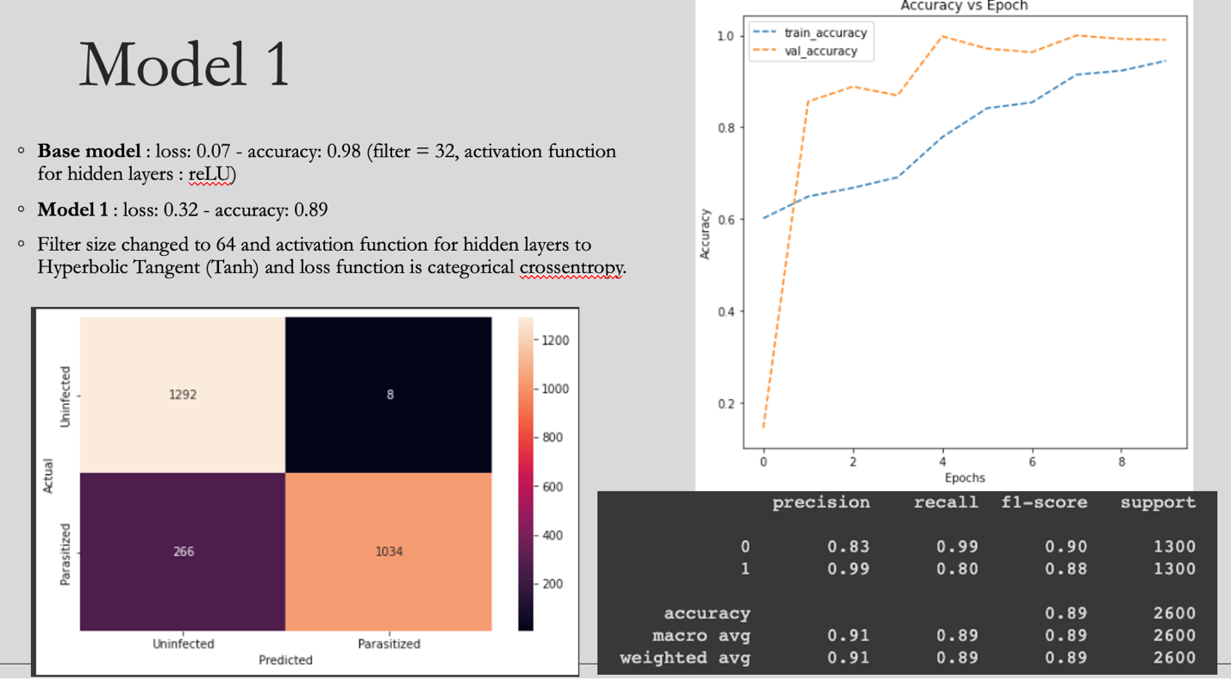

1. Vijayalakshmi A, Rajesh Kanna B Deep learning approach to detect malaria from microscopic images. Multimed Tools Appl 79, 15297–15317 (2020). https://doi.org/10.1007/s11042-019-7162-y